Saturday, 5 September 2026, postcard

The National Portrait Gallery and Six

I was on my own for breakfast again, so I headed over to Pret A Manger again, a little earlier than yesterday and arrived about 8:45 am, only to find that the day's supply of sandwiches and other savory foods wasn't expected until about 9 am. Still, among the scant stock, I found a small bacon and egg salad baguette that fit the bill.
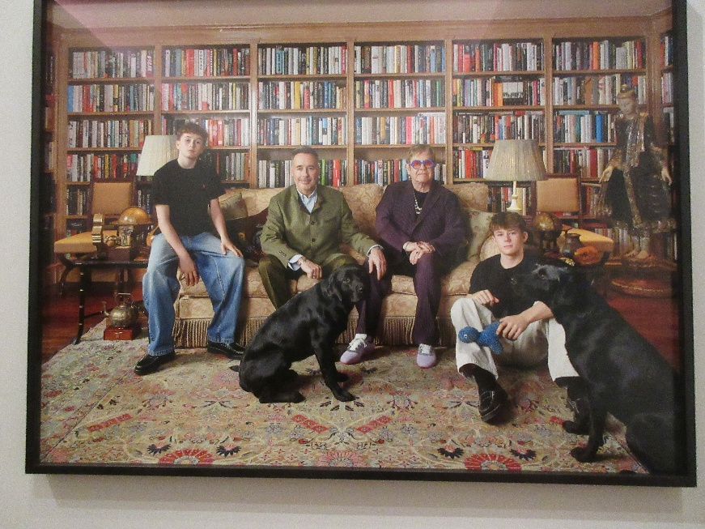
After breakfast I spent a little time on the computer doing research on our plans for the day (weather, route to the theater, opening hours, etc.), then strolled over to the National Portrait Gallery for their 10:30 am opening. I knew David would want to start at the top with the Tudors and work our way down, so I spent an hour working backwards, from the present upwards, so as to minimize overlap. I was especially struck by this photographic portrait of Elton John and his family.

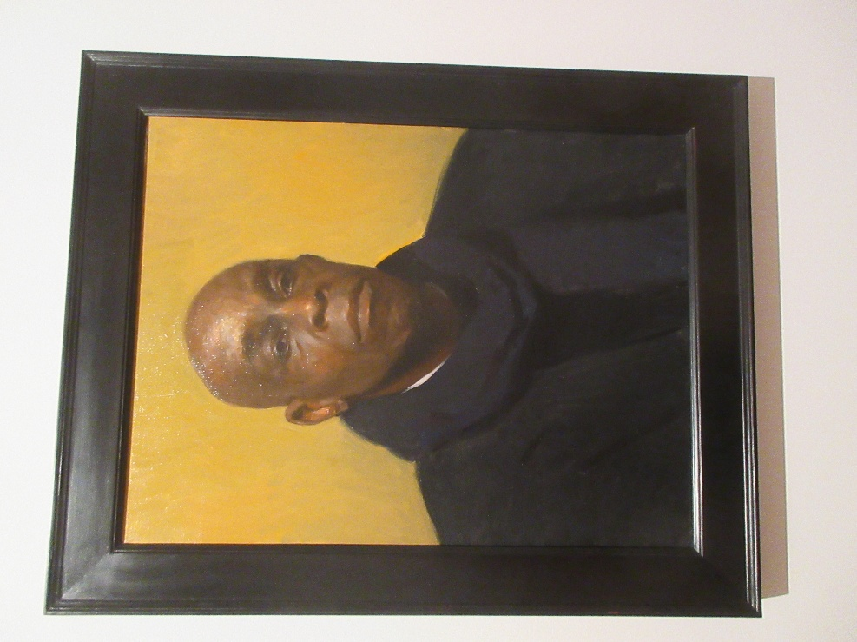
And this one, a painting by Marc Dalessio entitled "Jean-Denis," which took first place in the gallery's 2026 Portrait of the Year competition.

At 11:30 am, I was just on my way out to meet David at the hotel at noon when he called me to say he was up early, and was I ready? I hurried back, and we set out in search of lunch.

Because today was our 55th wedding anniversary, David promised to take me out to dinner and a show!

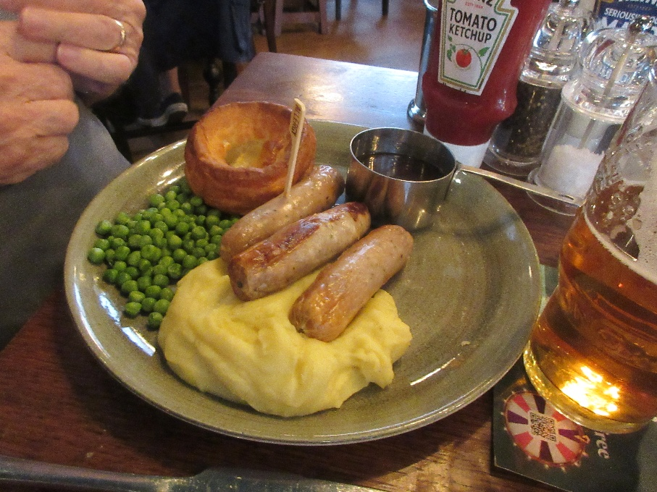
For lunch, he chose The Garrick, an authentic-looking pub next to the Garrick Theater, which turned out to be rather less authentic that it looked and which didn't have any real ales either. But the food was good.

David had the sausages and mash with garden (as opposed to mushy) peas, a miniature Yorkshire pudding, and a rich beef gravy. David is not fond of peas in general, and the Yorkshire pudding was pretty tough and dry, but the sausages and potatoes were very good.

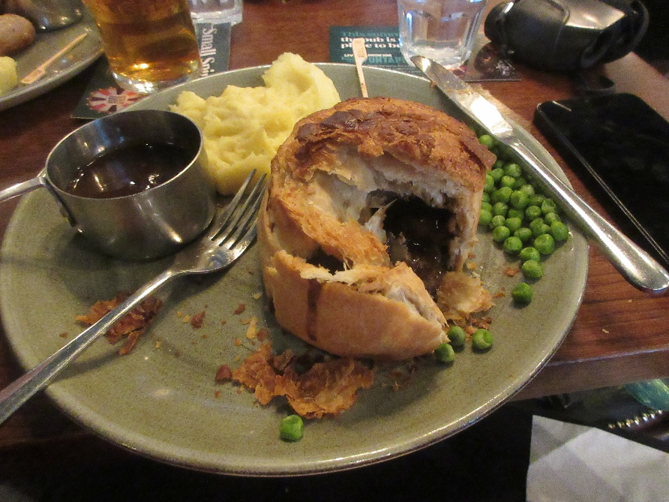
I ordered steak and ale pie, with the same peas, sauce, and potatoes—and I actually ate the peas. The pie was probably industrially mass-produced and only baked on the premises, but it was excellent nonetheless. I just wish somebody still made steak and kidney pie, the way my grandmother did. Now, it's always just steak and ale.

The little wooden picks stuck in our food are allergy flags. These days, they always ask if you have any food allergies, and as soon as we mention avocado and buckwheat, they (a) swear there are no avocados on the premises and (b) ask "what's buckwheat?," but the law says they still have to stick an allergy flag on each of our plates.

From the Garrick, we went back to the NPG, where we started at the top as recommended, with the portraits of the Tudors. At home, we have a slender but wonderful large-format paperback book called Royal Faces, which we actually refer to often, trying to make sense of history and literature. It has a page or two describing the reign of every British monarch and bearing at least one corresponding portrait. Turns out all those portraits are from the NPG, so we encountered "old friends" at every turn.

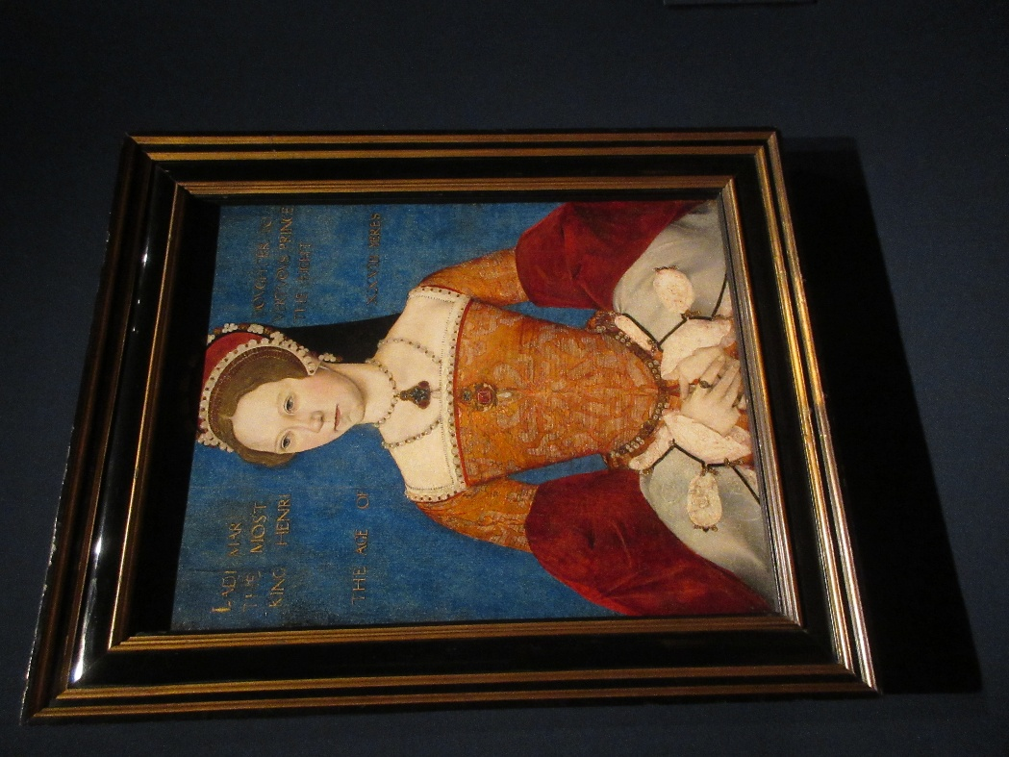
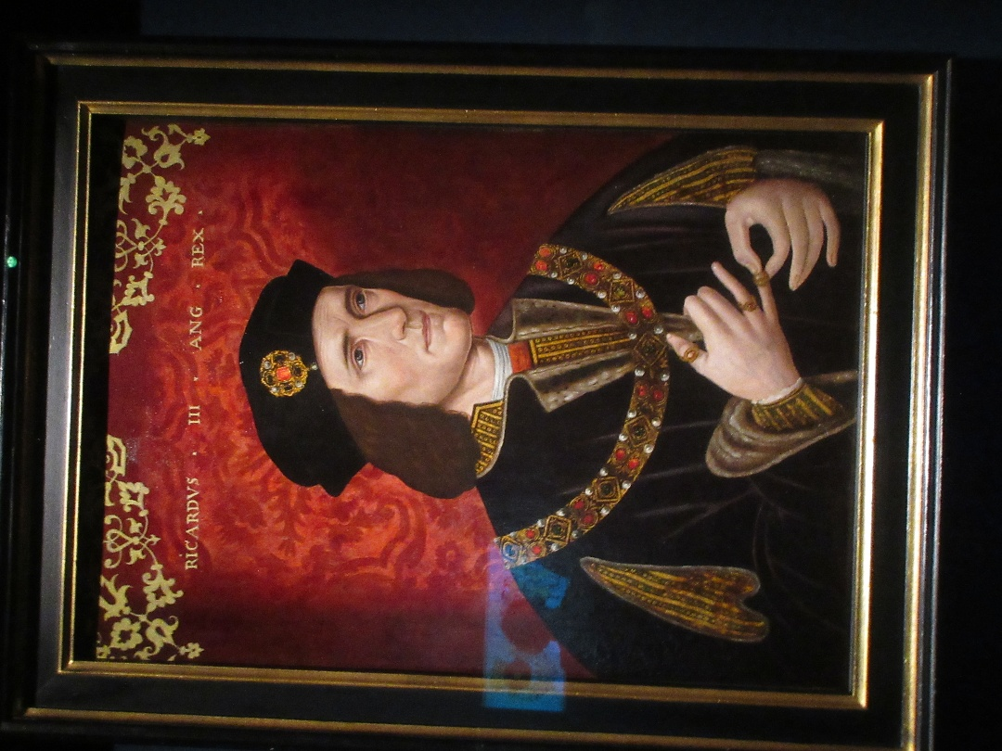
Here, for example is Richard III, and here, (Bloody) Mary I.

David wanted to go back to Steak and Co. for dinner, so we stuck our heads in there after lunch to make a reservation.

About 3 pm, we left the gallery and began the hike to the Vaudeville Theatre on the Strand for our 4 pm matinée of Six. A musical that started life in one of the directors' head as a vision of Henry VIII's six wives as members of a rock group. It was a hoot! They even allowed photos during the finale.

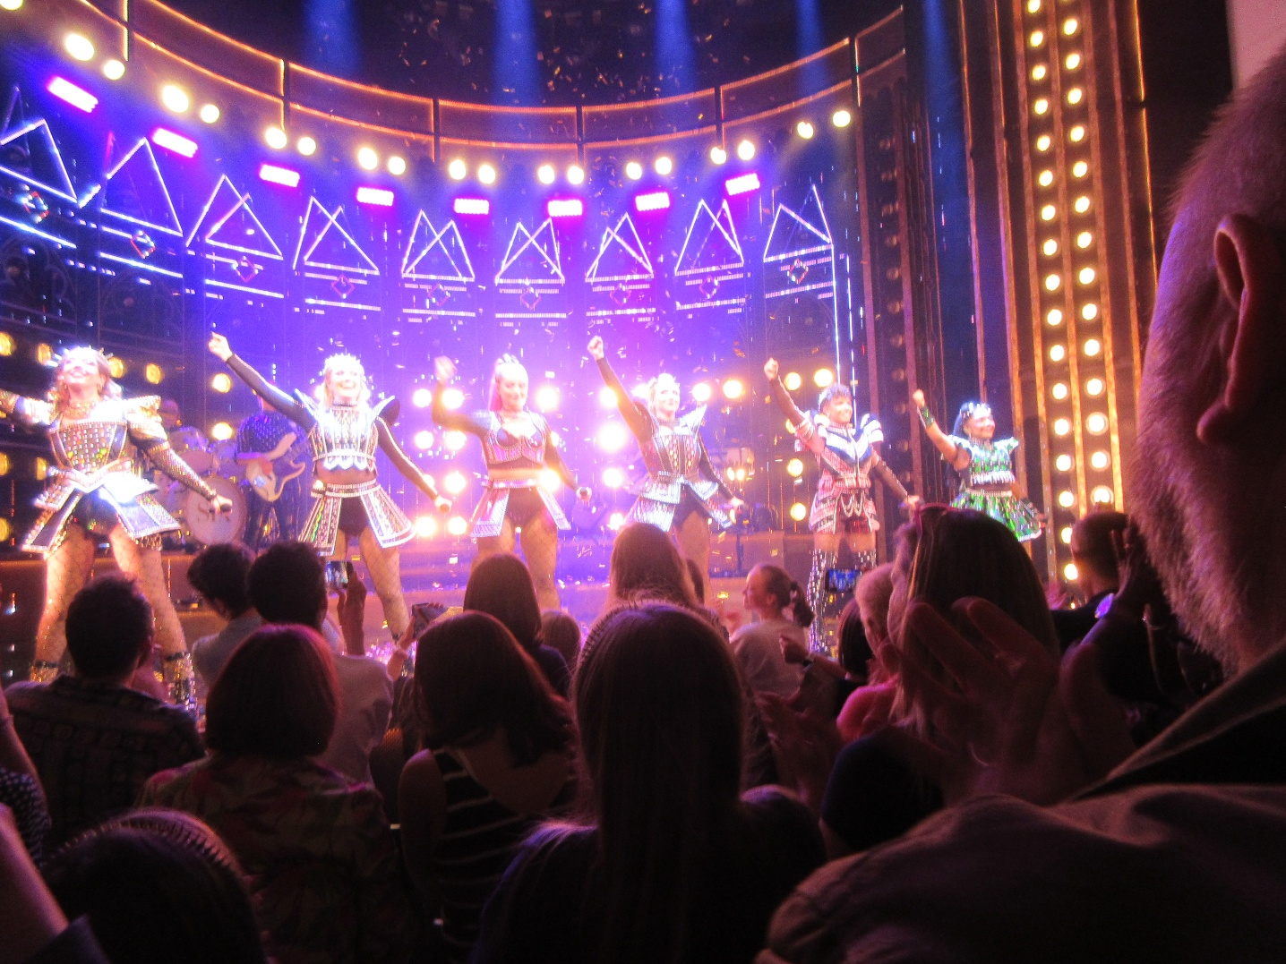

Back at Steak and Co. we ordered the same meal we had two nights ago (though I ordered green peppercorn sauce rather than béarnaise), and it was just as good;

